**LAB 14**

**TASK NO: 3**

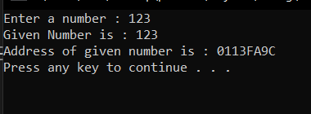**CODE: OUTPUT:**

#include<iostream>

using namespace std;

int main()

{

int* num;

int input;

cout << "Enter a number : ";

cin >> input;

num = &input;

cout << "Given Number is : " << input << endl;

cout << "Address of given number is : " << num << endl;

system("pause");

return 0;

}

**TASK NO 4:**

**CODE: OUTPUT:**

#include<iostream>

using namespace std;

int main()

{

int num1 = 123;

int num2 = 332;

int* p, * q;

p = &num1;

q = &num2;

cout << "Sum of tow numbers using POINTERS is : " << *p + *q << endl << endl << endl;

system("pause");

return 0;

}

**TASK NO 5:**

**CODE: OUTPUT:**

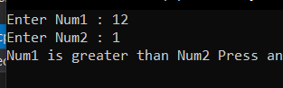#include<iostream>

using namespace std;

int main()

{

int num1;

int num2;

cout << "Enter Num1 : ";

cin >> num1;

cout << "Enter Num2 : ";

cin >> num2;

int* p, * q;

p = &num1;

q = &num2;

if (*p > *q)

cout << "Num1 is greater than Num2 ";

else

cout << "Num2 is greater than Num 1 ";

system("pause");

return 0;

}

**TASK NO 7:**

**CODE: OUTPUT:**

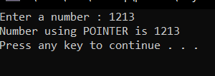#include<iostream>

using namespace std;

int main()

{

int num;

cout << "Enter a number : ";

cin >> num;

int* pointer;

pointer = &num;

cout << "Number using POINTER is " << *pointer << endl;

system("pause");

return 0;

}

**TASK N0 6:**

**CODE: OUTPUT:**

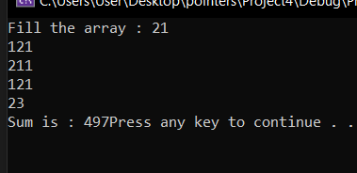#include<iostream>

using namespace std;

int main()

{

int arr[5];

int num = 5;

cout << "Fill the array : ";

for (int i = 0; i < 5; i++)

cin >> arr[i];

int* pointer;

int sum = 0;

for (int i = 0; i < 5; i++)

{

pointer = &arr[i];

sum = sum + *pointer;

}

cout << "Sum is : " << sum;

system("Pause");

return 0;

}

**PROGRAM NO2:**

**CODE:**

#include<iostream>

using namespace std;

int main()

{

//--aaaaaaa--in this part no ADDRESS OPERATOR is used with pointer in cout statement

int* number;

/*cout <<&number << endl;*/

//--bbbbbbb--wrong

/*double* realPtr; **OUTPUT:**

long* integerPtr;

integerPtr = realPtr;*/

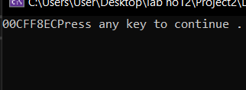 //--bbbbb--Correct

double* realPtr;

double* integerPtr;

integerPtr = realPtr;

//--cccccccc-----WRONG

/*int* x, y;

x = y;*/

//--ccccccc-----Correct

int* x, y;

x = &y;

//--dddddddd---WRONG

/*double x = 19.34;

double xPtr{ &x };

cout << xPtr << endl;*/

//--dddddddd--CORRECT

int x = 19.34;

int* xPtr;

xPtr = x;

/*cout <<"Faraz " << xPtr << endl;*/

system("pause");

return 0;

}

**TASK NO 1:**

#include<iostream>

using namespace std;

int main()

{

long value1 = 200000, value2;

//--aaaaaaa--

char* charPtr;

//--bbbbbbb--

char var1;

char var2 = 32;

charPtr = &var2;

//--cccccccc--

cout << *charPtr;

//--ddddddd--

var1 = *charPtr;

//--eeeeeeee--

cout << var1;

//--ffffffff--

cout << &var2;

system("pause");

return 0;

}